Coffee Chain
A Business Analysis
Introduction
In the modern world, those organizations that implement analytics can have an edge over the competition.
It is made possible by the analysis of basic performance indicators, including sales, stock levels, expenditure on promotion and many other business strategies.
The strategy also ensures efficient management of resources to achieve overall synergy between organizational objectives, market needs and financial resources
The overarching intention of this paper is to examine the data accumulated from the coffee’s chain’s systems and highlight trends and correlations existent, which can inform business decisions.
More specifically, we will examine how different factors, including promotion, the price of inputs, and the scope of activities, affect the final profits of the company.
The interest of our study to the coffee chain is the search for ways to increase sales, lower various costs, and improve the profitability of the chain in various countries and product lines.

Business Problem

The coffee chains presented in this dataset are struggling with fluctuating profitability and productivity in their various markets and areas of products.
Even in the presence of set targets, real profits earned and costs incurred tend to differ often, which brings about lost sales and needless expenditures which results in wastage of resources.
Such inconsistencies suggest that there may be some blurred lines in the areas of resource distribution, pricing, inventory, and effectiveness of marketing activities. For example, certain specific regions or product categories might have too much stock which may lead to increased stockholding costs and wastage, whereas areas with most demand are understocked and lose their revenue-generating opportunities.
At the same time, marketing costs in some areas may be high and the returns are lower leading to wasteful expenses without increasing sales. Such a structural imbalance points to the necessity of a better working practice regarding demand prediction, inventory management, and control, as well as expenditure for various purposes so as to reduce costs while boosting returns.

Dataset Variables
The dataset consists of 4,251 records and 21 columns in total and the key variables are:
Column Name | Data Type | Description
Area Code | int64 | Numeric area code identifier for each location
Ddate | object | Date in MM/DD/YYYY format
Market | object | General market region (e.g., Central, Eastern)
Market Size | object | Size category of the market
Product | object | Product name
Product Type | object | Type of product (e.g., Coffee, Espresso)
State | object | U.S. state
Type | object | Product type detail (e.g., Decaf)
Budget Margin, Margin | float64 | Profit margin (budgeted and actual)
Budget Profit, Profit | float64 | Profit (budgeted and actual)
Budget Sales, Coffee Sales | int64 | Sales (budgeted and actual)
Inventory | object | Inventory stock for each entry
Marketing | float64 | Marketing expenses
Total Expenses | float64 | Sum of costs associated with each record

Objectives
The primary goal of this analysis is to uncover actionable insights that will help the coffee chain optimize its operations and improve overall performance.
By analyzing the data, we aim to tackle key challenges like improving forecasting accuracy, optimizing inventory levels, and reducing unnecessary costs.
Ultimately, this analysis will help the coffee chain make data-driven decisions that enhance efficiency, boost profitability, and strengthen its market position
Analysis
- Regional Product Distribution:
To identify regional preferences, market dominance, and opportunities for strategic adjustments in marketing, production, and resource allocation, we need to analyze both the demand and supply factors across different geographic regions. By examining variations in product performance, sales trends, and customer behaviors in each region, we can uncover key insights into consumer preferences, seasonal trends, and price sensitivity.
This analysis can help pinpoint which products are driving sales in high-demand markets and which are underperforming in others, revealing gaps or opportunities for expansion. Additionally, understanding regional demand allows for more efficient resource allocation—optimizing inventory levels, tailoring marketing efforts to regional tastes, and adjusting production volumes based on local sales patterns.
Furthermore, identifying dominant markets and underperforming regions can guide investment decisions, enabling businesses to focus efforts on profitable markets while developing strategies to enhance performance in weaker regions. This approach supports smarter decisions regarding pricing strategies, promotional tactics, and partnerships, ultimately improving operational efficiency and profitability across diverse regions.

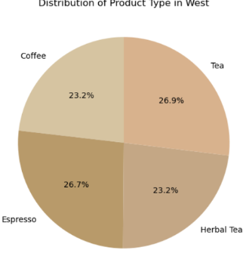
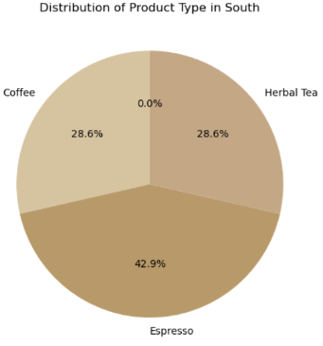
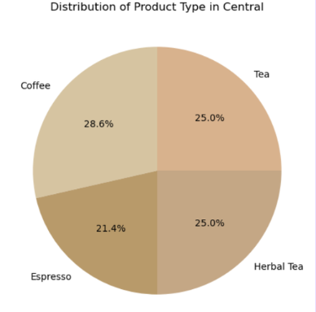
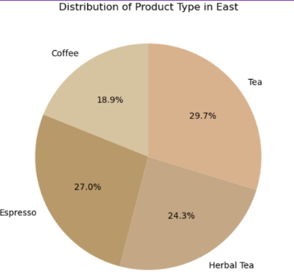

- Identifying Regional Imbalances:
The objective of this analysis is to identify regions that may be over-represented or under-represented in terms of the coffee chain’s market presence, enabling the company to strategically refine its approach to market expansion and resource allocation.
By systematically identifying both over-represented and under-represented regions, the coffee chain can ensure that its expansion strategy is well-balanced. This analysis will provide the company with a comprehensive understanding of where to focus efforts for growth, where to consolidate or optimize existing operations, and how to maintain a competitive edge in a dynamic market.
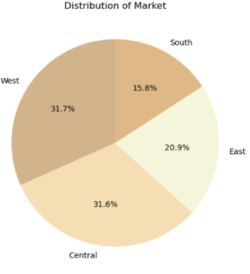
- Marketing Campaign Effectiveness
The objective of this analysis is to measure the impact of marketing efforts to help the coffee chain optimize advertising spend and maximize return on investment (ROI). In a highly competitive market, understanding the effectiveness of marketing campaigns is essential for allocating resources wisely and ensuring that every dollar spent on advertising delivers maximum value. By evaluating the relationship between marketing expenditure and key performance indicators such as sales, profit margins, customer acquisition, and brand awareness, the company can refine its marketing strategies to achieve greater efficiency and better financial outcomes.
Graph:
Line graph comparing sales before, during, and after marketing campaigns across various channels (social media, email, etc.).

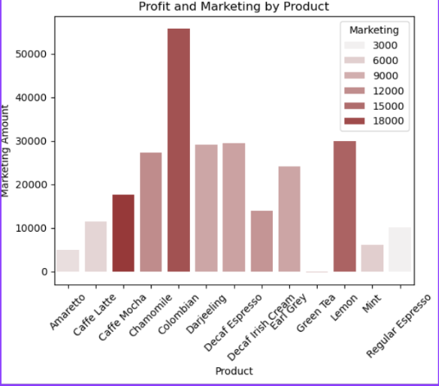

- Product Line Performance
The aim of this analysis is to look for the best performing products with an option of making losses by stopping to produce the worst performing items altogether to increase profit. The organization would be able to efficiently manage its operations as well as lower its costs and enhance its profitability by rationalizing its product mix with market demands and product margins. The analysis further seeks to determine the products that are most and least productive in terms of revenue and margins and the reasons for these products being part of the company’s portfolio when they are so unproductive.
• Graph:
Bar chart determining profit for each product type (e.g., espresso, latte, cold brew).

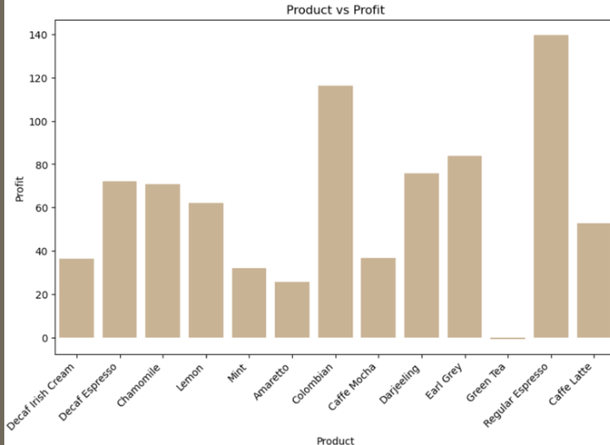
- Market Financial Performance: Expenses vs Profit Comparison:
The objective of this analysis is to visualize the total expenses and profit across different regions to assess market efficiency, pinpoint areas for cost control, and evaluate overall profitability in each market. By analyzing these key financial metrics, the coffee chain can gain valuable insights into the performance of individual markets, identify inefficiencies, and make informed decisions about where to allocate resources most effectively to maximize profitability. This analysis also provides a clearer understanding of the financial health of each region, enabling better strategic planning and optimization of business operations
Graph:
A scatter plot that shows the relationship between Marketing Expenditure and Profit, differentiated by Product.
Bar chart determining profit for each product type (e.g., espresso, latte, cold brew).
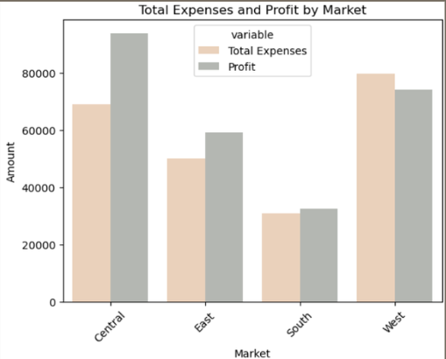

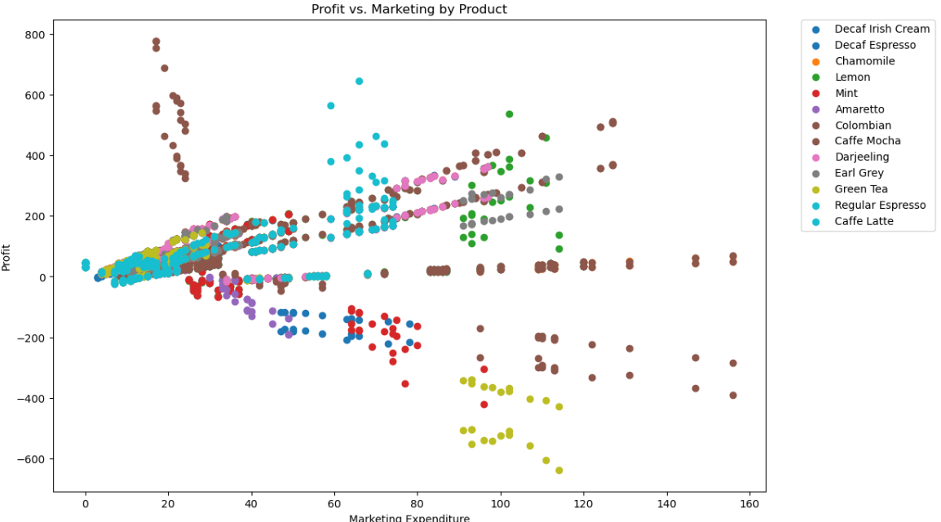

- Product Financial Performance: Expenses vs Profit by Product Type:
The primary objective of this analysis is to identify which products are more profitable, which are costlier, and use this information to inform decisions for product optimization. By closely examining the performance of individual products in terms of profitability, cost structure, and sales volume, the coffee chain can make informed, data-driven decisions that optimize its product portfolio, streamline operations, and enhance overall profitability. This objective aims to not only evaluate the financial contribution of each product but also to understand how various cost factors impact their overall success, allowing for strategic product adjustments and more targeted resource allocation.
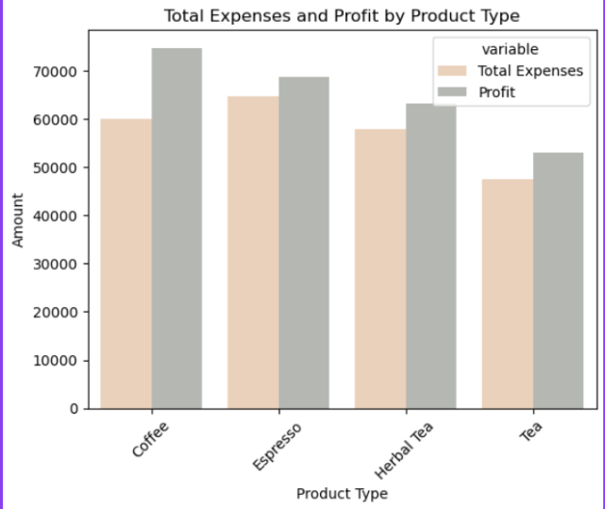

The bar chart displays total expenses and profits for each regional market side by side.

- Comparing Market Performance Across Profit, Margin, and Coffee Sales:
By enabling the careful assessment of key performance measures, the coffee chain can gain relevant insights about its regions’ performances, adjust their strategies accordingly, discover strengths and weaknesses, and use them to bolster their reach in the respective area Both historical and more real time looking tools such as visual representations of sales figures, cost, and even ad effectiveness can help the management respond more quickly to the operational level with relative activities that fit both short term and strategic objectives. In the end visualization in this case helps the coffee chain to transform its strategies, design new products, and survive and grow in a highly competitive environment.
Graph 1 :
Displays a heatmap showing the total Profit, Margin, and Coffee Sales for each Market, with annotated values and a color scale to represent the magnitude of each value.

Graph 2:
A bar plot compares the Profit, Margin, and Coffee Sales for each Market.

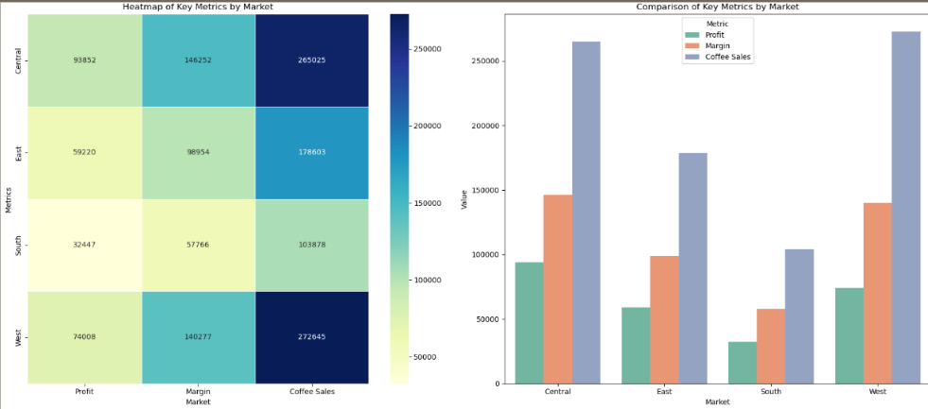

- Time Series Analysis of Profit Trends
Identifying patterns, fluctuations, and trends in profitability across different time periods is critical for gaining a deeper understanding of the financial health of the coffee chain. By analyzing profitability over time, businesses can make informed decisions, plan for the future, and optimize operations to drive sustained profitability.
Graph:
The time series plot displays profit values on the y-axis and date on the x-axis, showing how profit evolves over time

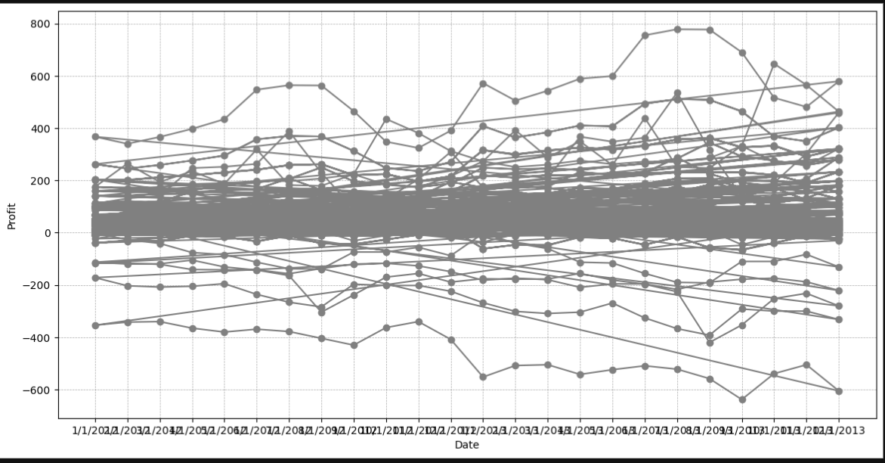
- Market Comparison: Budget Sales vs Coffee Sales
Understanding the relationship between budgeted sales (predicted or planned sales figures) and actual coffee sales (the actual sales performance) is critical for evaluating how well a business is performing relative to its expectations. By analyzing this relationship within different regions, businesses can gain valuable insights into their sales performance and market-specific trends.
Graph:
A grid of line plots, with each plot representing a different marketshowing a clear comparison of how Budget Sales correlate with Coffee Sales in each region

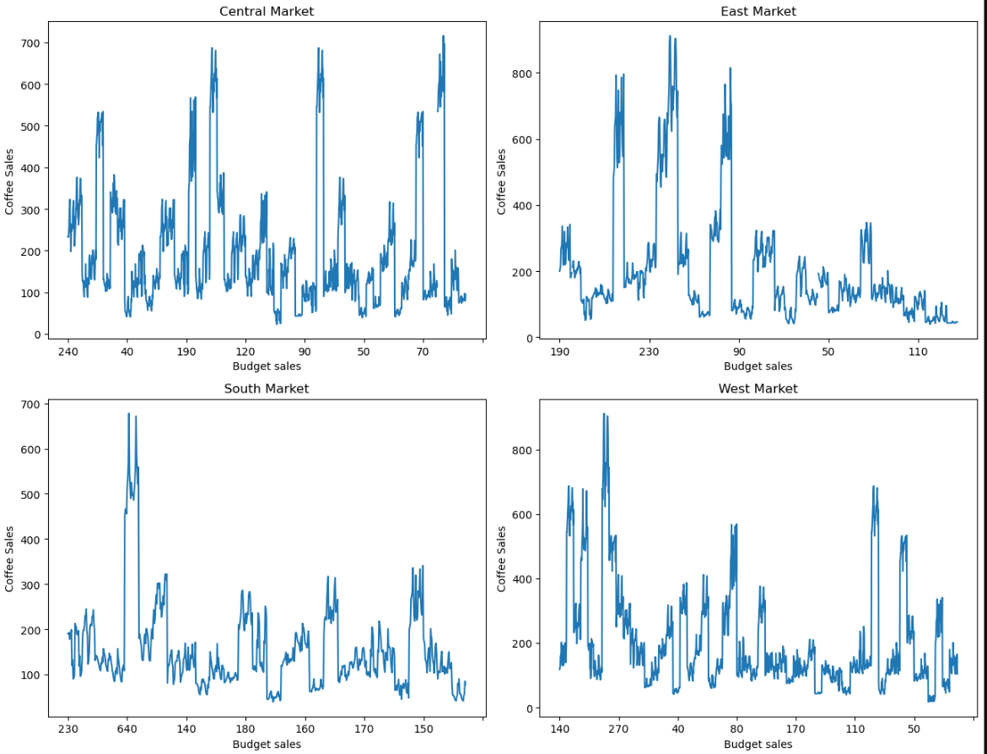
- Financial Performance Comparison Across Market:
In order to evaluate the financial health and operational efficiency of a coffee chain, it is crucial to systematically compare actual financial outcomes with budgeted expectations. By examining discrepancies between actual values (such as profit, costs, sales, and margins) and budgeted targets across different markets, businesses can identify key areas of concern, uncover opportunities for improvement, and fine-tune their strategies. This analysis helps ensure that resources are being utilized effectively, margins are optimized, and costs are being controlled appropriately.
Graph 1: Profit vs Budget Profit TThis line plot compares actual Profit (in navy blue) against Budgeted Profit (in brown) across different markets.
Graph 2: Budget Margin vs Actual Margin This line plot compares Budget Margin (in orange) and Actual Margin (in purple) for each market.
Graph 3: Budget COGS vs Actual COGS This line plot compares Budgeted Cost of Goods Sold (in red) and Actual COGS (in green) across different markets

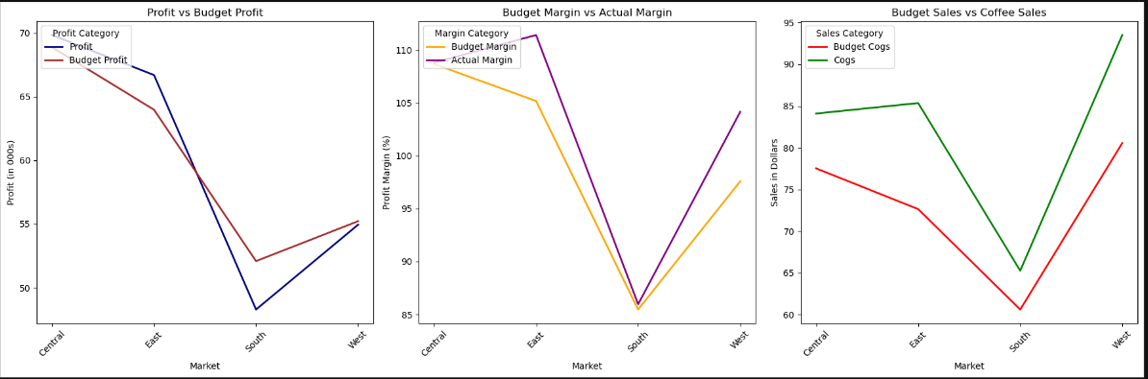

- Strategic Product Adjustments
Visualizing profit fluctuations over time across different product categories plays a critical role in understanding both the short-term and long-term trends that affect a business's bottom line. This type of analysis not only helps track the overall performance of each product but also highlights underlying patterns that can be leveraged for strategic decision-making. By focusing on profit trends within specific product categories, businesses can identify growth opportunities, declining segments, and seasonal variations that can significantly impact operations, marketing, and inventory management.
Graph:
Line plot illustrating the profit trends over time for each product category, with color-coded lines for easy comparison of performance across different products.

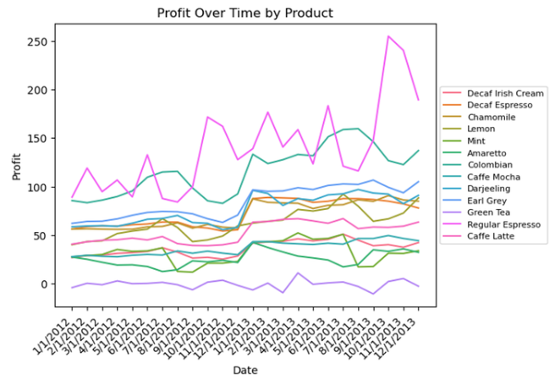

- Benchmarking Coffee Chain Profitability
Benchmarking the coffee chain's financial performance involves comparing its actual profit distribution to internal targets, historical performance, and industry standards or expected profit margins. This form of analysis offers invaluable insights into how well the business is performing in relation to its goals and market expectations. By analyzing profit data against these benchmarks, the company can uncover areas of both strong performance and underperformance, as well as assess how it is progressing toward achieving its broader financial and strategic objectives.
Graph:
The plot shows the distribution of profit in the dataset, with a histogram that divides the data into 30 bins and an overlaid KDE curve that smooths the distribution.

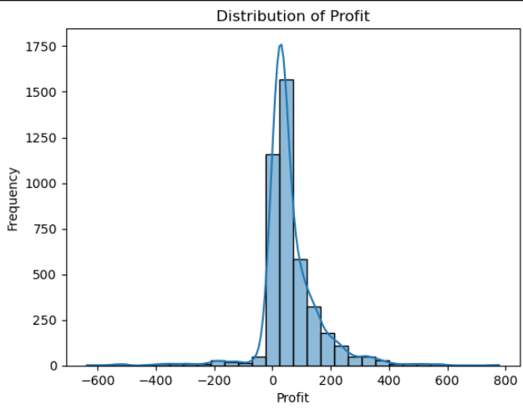

- Optimizing Inventory Management:
Effective inventory management is crucial for maintaining an efficient supply chain, minimizing operational costs, and ensuring that products are available when needed without overstocking or understocking. One of the primary strategies for optimizing inventory is to accurately forecast demand based on seasonal trends and sales fluctuations. By identifying seasonal sales peaks and low-demand periods, businesses can adjust their stock levels to ensure they meet consumer demand while reducing the risk of excess inventory or stockouts.
Graph:
A line plot showing the monthly total coffee sales trend .

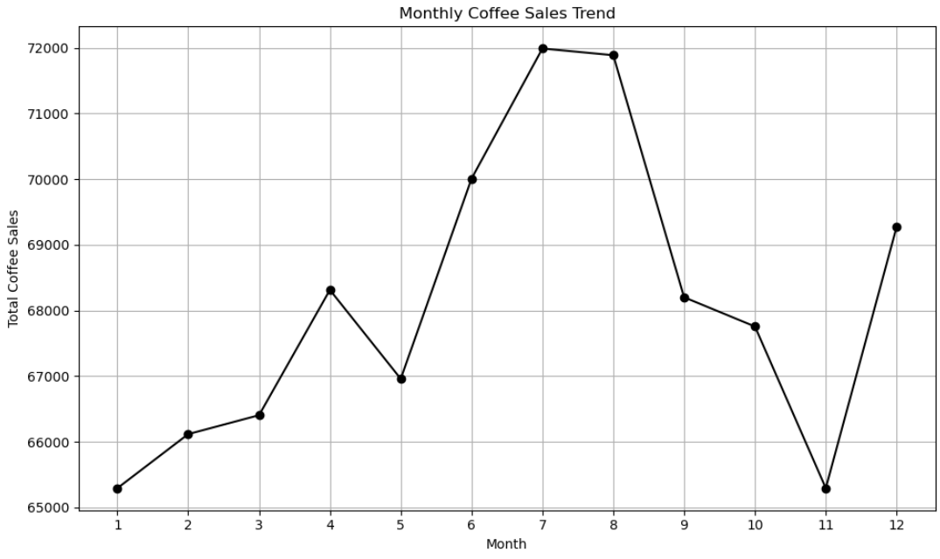

- Enhancing Inventory Efficiency
In any business, especially those with varying demand patterns like a coffee chain, maintaining a balance between stock levels and sales is crucial for operational efficiency. Discrepancies between these two metrics—where the inventory doesn’t align with actual sales trends—can lead to a number of challenges, including stockouts, overstocking, higher operational costs, or missed sales opportunities. Identifying these discrepancies allows businesses to refine their inventory management strategies and ensure that stock levels are optimized to meet customer demand while minimizing excess or insufficient stock.
• Graph:
The bar plot compares yearly coffee sales and yearly inventory totals, with the x-axis representing the years and the y-axis showing the corresponding sales and inventory values.

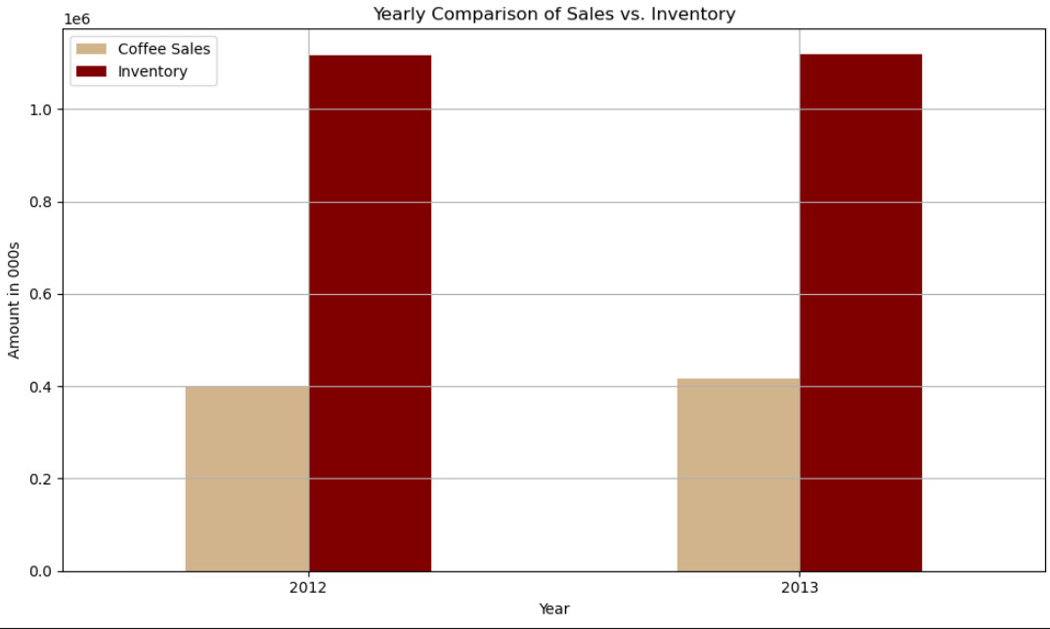
- Overall Analysis:
From the dataset, key metrics such as Profit, Margin, Coffee Sales, Budget COGS, Budget Profit, and Total Expenses across different markets provide valuable insights into the company’s performance. By analyzing visualizations like heatmaps, bar plots, and monthly sales trends, we can derive the following key observations:
Sales and Profit Fluctuations:
- Monthly Coffee Sales Trend: The dataset indicates noticeable fluctuations in coffee sales over time. For example, months like June and July see a significant spike in sales, likely due to seasonal demand, while January and February show relatively lower sales, which may be attributed to post-holiday lulls and lower consumer spending. This highlights a seasonal pattern in coffee sales that should be factored into operational planning.
Market Performance and Profitability Gaps:
- Profit vs. Budget Profit: Discrepancies between actual and budgeted profits are evident across markets. For instance, the Central Market consistently exceeds budgeted profits, suggesting strong over-performance in that region. Conversely, certain other markets show a shortfall in actual profits compared to budgeted targets, indicating potential areas of underperformance or misaligned expectations. Addressing these discrepancies will help optimize profit across all regions.
Inventory Management Discrepancies:
- Inventory Levels: Inventory fluctuates from month to month, sometimes surpassing sales figures, indicating potential overstocking, especially in months like June and July. In other months, such as post-holiday periods, understocking may occur. This suggests a misalignment between sales and inventory management, which could lead to either excess holding costs or missed sales opportunities due to product shortages.
Cost Structure & Margin Issues:
- Budget COGS vs. Actual COGS: In some months, actual cost of goods sold (COGS) exceeds budgeted amounts, affecting profit margins. For instance, June shows a higher-than-expected COGS ($123 per unit vs. a budget of $130), despite strong sales performance. These discrepancies suggest inefficiencies in the cost structure that need to be addressed, such as renegotiating supplier contracts or optimizing supply chain processes.
Regional Product Performance:
- Regional Variations in Product Demand: The analysis also reveals distinct regional preferences for certain coffee products, with premium products (e.g., high-end blends) performing better in high-income regions like North America, while mid-range offerings (e.g., standard blends) are more popular in price-sensitive markets like Asia-Pacific and Latin America. This regional differentiation underscores the importance of tailoring product offerings to match local tastes and economic conditions. Markets in EMEA also show an increasing demand for eco-friendly and sustainable products, with certain coffee lines performing better due to their environmentally conscious appeal
- Solutions:
Based on the insights from the data and visualizations, the following solutions are recommended to improve the business's performance:
- Optimize Inventory Levels:
  - Issue: There is a mismatch between sales and inventory, with overstocking in some months (like June and July) and potential understocking in others.
  - Solution: Implement a demand forecasting model that considers seasonality to better align inventory with sales trends. This could involve adopting a just-in-time inventory strategy to reduce excess stock and holding costs, while ensuring stock levels remain adequate during peak sales periods.
- Align Actual Profits with Budgeted Targets:
  - Issue: Some markets consistently exceed budgeted profits, while others fall short, indicating a misalignment in expectations.
  - Solution: Revise the budgeting process to incorporate real-time data and market performance. This will allow more flexible adjustments to profit targets and budgeting goals, helping the business set more accurate and achievable financial expectations across diverse regions.
- Cost Optimization Strategies:
  - Issue: Some months exhibit higher-than-expected COGS, reducing profit margins.
  - Solution: Conduct a cost audit to identify inefficiencies and overrun areas. Focus on negotiating supplier contracts, streamlining supply chain processes, and applying lean management techniques to reduce operational costs without compromising product quality or customer satisfaction.
- Seasonal Sales and Marketing Strategy:
  - Issue: Sales fluctuations are observed, with peaks during certain months (e.g., summer) and dips in others (e.g., January and February).
  - Solution: Develop targeted seasonal marketing campaigns to boost sales during slower months, while maximizing opportunities during peak months. For example, offer summer promotions on high-demand products and post-holiday promotions with discounts or loyalty programs to encourage repeat purchases.
- Improving Margin Performance:
  - Issue: Some markets are achieving strong profits, while others have lower margins despite similar sales.
  - Solution: Analyze cost structures in low-margin markets and explore pricing optimization strategies. Adjust prices where possible to improve margins, particularly in regions where costs are disproportionately high. Additionally, promoting higher-margin products and fine-tuning the product mix could enhance profitability.
- Leverage Regional Insights for Product Optimization:
  - Issue: Regional performance data shows varying consumer preferences, with certain products performing better in specific regions.
  - Solution: Tailor the product offering to meet regional preferences—e.g., emphasize premium blends in high-income markets like North America, while focusing on affordable, mid-range options in price-sensitive regions like Latin America. Additionally, in regions such as EMEA, where sustainability is a growing trend, promoting eco-friendly products could create a competitive edge.
- Conclusion
In conclusion, optimizing inventory levels, aligning profits with budgeted targets, and refining cost management strategies will significantly enhance operational efficiency and profitability. By closely monitoring and adjusting inventory levels to meet demand fluctuations, the coffee chain can prevent issues such as stockouts and overstocking, ensuring that products are available when needed and minimizing excess inventory that ties up working capital. This will also reduce operational costs associated with storage and logistics, leading to a more efficient supply chain. Additionally, aligning profits with budgeted targets helps the business ensure it is on track to meet financial goals, identify areas where it may be falling short, and make adjustments in real-time to maximize profitability.
By focusing on these strategic areas—inventory optimization, cost management, regional product customization, and seasonal marketing—the coffee chain can drive sustainable growth. It will be better equipped to adapt to market changes, reduce inefficiencies, and meet consumer demands year-round. This approach ensures that the business remains competitive, profitable, and capable of delivering value to customers across different markets, ultimately positioning itself for long-term success. Moreover, focusing on these areas fosters agility within the organization, enabling it to swiftly respond to emerging trends, seasonal demands, and shifting consumer preferences.
In essence, these strategies not only improve current performance but also lay a strong foundation for the company’s continued expansion and growth, positioning the coffee chain as a leader in the market while enhancing its operational resilience and market adaptability.

Meerub Nadeem 24L- 5741
Syed Zain Ali 24L-5618
Zahid Abid 24L - 5518
Hadia Inayat 24L - 5559
Affaf Kashif 24L - 5508
Umer Zahid 24L- 5647

